MK 469 A1
Zipcar: Market Analysis and Research Insights
Deliverable # 2
Team 3
10/24/2011

Danyelle Jones, Josh Li, Riho Hayashi, Jon sei Yi

JJ.RD Consulting, LLC is one of the Top 100 advertising agencies in the United States, carrying many clients who value new, creative advertising methods specifically geared toward younger generations. Our past clients include Panasonic, Pink Berry, and Ame & Lulu. Founded in Boston in 2003, we continue to execute unconventional and eye-catching advertisements within the greater metro areas around the United States.

Competitive Analysis
Zipcar has two major competitors who have developed similar car sharing concepts; however, they have emphasized different benefits through their individual advertising efforts.
Hertz on Demand- Connect by Hertz
- Functional Benefits:
  - Free membership
  - Convenient airport returns
  - GPS navigation included
  - One-way car sharing rentals
- Emotional Benefits:
  - Reliability
  - Trust
  - Safe
- Advertising Efforts:
  - Aggressive Market Gain Strategy
    - Trading competitor membership card for credit in Hertz service
      - “Give it Up, Get More” Promotion
    - Direct comparisons to Zipcar
  - Social Media
    - Facebook Page- 2421 likes, personal respondents dealing with problems and casual questions and interactions
- Overall Message:
  - We offer the superior and cheaper choice, why pay more?
Enterprise WeCar
- Functional Benefits
  - Affordable,
  - Lower age requirement
- Emotional Benefits:
  - Community
  - Sharing
  - Environmentally friendly - hybrid cars, economic cars
  - Control
  - Reliability - largest company
- Advertising Efforts:
  - Bland and weak advertisement - web-side banners
  - Website - stiff, feels old, out of date
  - Facebook- not integrated, small factions of regional joints
- Overall Message:
  - We offer environmentally friendly car sharing service to people in need, especially younger students in college.
From these insights we developed a positioning map. WeCar developed its character strongly around being environmentally friendly. However, their advertising lacks vibrancy and life, and fails to distinguish itself as something hip and new. Hertz on the other hand, aggressively attacks Zipcar’s position with enticing offers. Hertz’s promotions are stylish and connect with their target consumer, but the brand lacks the distinctive and substantive identity of Zipcar.

Trends in the Marketplace
Zipcar’s market leader position in the car-sharing industry stemmed from the fact that it had a strong “first mover’s advantage” but is sustained by a strong Net Promoter System. However, in ten years, Zipcar has yet to demonstrate profitability, affected mainly by aggressive acquisitions and the high costs of new vehicle procurement. To be successful in the long run, it is imperative for Zipcar to capitalize on global market expansion opportunities and prove that it can be sustainably profitable with its’ high user utilization strategy.
Strengths:
- First Mover Advantage – While car sharing has been around since the 1970s in many parts of Europe, Zipcar Inc. was the first firm to bring the concept to the US in a systematic multi-city business model. Unlike traditional car rental companies, Zipcar allowed its’ members the freedom of getting a car without the need to interact with a front office.
- Net Promoter Score Industry Leader – Zipcar’s main strategy for sustained competitive advantage is in creating and sustaining a very high level of NPS. According to Fred Reichheld (the creator of NPS), the average company has a Net Promoter Score of 5% - 10% while the best companies with strong growth engines have a NPS of 50% - 80%. During the last Zipcar company-wide meeting, Reichheld calculated that Zipcar had an NPS of approximately 61%.
- Aligned with Market Trends – Zipcar’s overall mission, to reduce car ownership is consistent with general market trends towards creating more environmentally friendly transportation solutions. In addition, the current volatility of the economy creates disincentives for younger consumer segments to purchase their own personal vehicles.
Weaknesses:
- High Initial Vehicle Costs – Zipcar faces the constant challenge creating a high level of utilization (to offset high fixed costs of new vehicle acquisitions/replacements) and balancing that with customer complaints of car unavailability. However, Zipcar will be able to leverage its’ expanding market leadership (and the economies of scale with that position) with car manufacturers to secure better deals of procurement, i.e. partnership with Ford Motors for “Students with Drive” campaigns.
- Seasonality of Service – While some “Ziptrips” are immune to seasonality, i.e. grocery shopping, errands, commuting to work/school, the longer weekend trips that many Zipcar members are greatly affected by seasonality. This is reflected in the membership gains in the warmer summer months, utilization rates across seasons, and the lower pricing rates of the colder winter months.
Opportunities:
- Market Expansion Opportunities in University & Z4B markets – The primary Zipcar customer exists in high population metropolitan cities but the Zipcar model has been recently expanded into two growing markets of universities and local businesses. Zipcar can continue to grow on these markets without the significant costs in physical and labor capital that other car rental models will incur.
- Expansion into Global Markets – With the recent acquisition of London-based competitor, Streetcar Inc, Zipcar is able to aggressively expand its’ presence into the European markets in the coming years.
- Potential Partnerships with “New Urban” Transportation Sharing Programs –Zipcar sees itself as a company that is a part of a larger transportation system with partnerships with local public transportation authorities. As new alternative transportation solutions emerge, such as Hubway’s bike-sharing program, Zipcar’s market leader position lends itself to attract potential partnerships.
Threats:
- Traditional Rental Car Companies – In the past, companies such as Enterprise, Hertz and Avis had all waited for Zipcar to demonstrate that its’ business model can be a profitable before entering the car-sharing space. Presently these larger companies, which have much higher economies of scale, have entered the space and are aggressively attacking Zipcar’s market leader position with promotions to steal market share.
- Small Scale Local Car Sharing Programs – Smaller localized car-sharing programs such as Chicago’s I-GO Car sometimes band together in associations to achieve better economies of scale to compete with Zipcar.

Consumer Insights Analysis
From our analysis we found a few basic things about college students and their feelings towards transportation. College students generally feel very confined to the limitations of transportation that doesn’t include a car, such as walking, taking a train, or riding a bus. For these students cost, reliability, and convenience we’re some of the most important things they took into consideration when choosing which mode of transportation was best for them dependant on the activity they were pursuing. Overall, we found that driving a car was nearly every student’s favorite form of transportation. Cars, when available, were considered to be faster, easier, and allowed for more freedom to travel. However, many considered the cost of owning a car in an urban area to be prohibitive. We learned mainly from interviews that given Zipcar as an option, many college students we unaware of the brand and if they did know about it, they were unsure of how the process worked and the cost of the service overall. Additionally, many students thought Zipcar wasn’t for them because of age requirements.

From this research we have discovered two key challenges Zipcar must face:
- Increasing consumer understanding of the brand, the attributes, and benefits Zipcar provides
- Increasing overall awareness of the brand and targeting the service as something that is for them

With these challenges we have also found two major opportunities Zipcar can capitalize on:
- Students who don’t know much about Zipcar know that it is different from traditional car rental and consider it to be trendy and hip
- Overall students feel confined in the places they can go, they want more freedom, and more of an ability to go wherever they want to go

By targeting advertising based on these opportunities to students and informing them of the benefits Zipcar can provide them, they can overcome these challenges. We have found many functional and emotional benefits Zipcar possesses which we can take advantage of to reach this demographic and gain new customers. These include:
Functional Benefits
- Convenience
- Convenience of location - easily accessible
- Flexibility - return times, opt out of insurance, return without full gas
- Accessibility to younger target
- Affordable

Emotional Benefits
- Independence
- Freedom
- Socially responsible
- Reliability
- Cool, hip

From our research, we have developed a positioning statement that encompasses these ideas and summarizes the approach we will take to increase brand awareness among college students and expand into this new market.

Positioning statement for the brand:
- Zipcar is a flexible and affordable way to empower your mobility and enrich your lifestyle.

Finally, we developed one simple thing to say about Zipcar, which will be the basis for future advertisements.
- Friends with Benefits
Owning a car is a significant financial commitment – one that most college students can’t afford. Zipcar gives college students all the benefits of car ownership without the commitment (financial and otherwise). This message resonates deeply with the typical commitment phobic college student by emphasizing convenience, accessibility and freedom. Zipcar is more than just a one night stand, it’s reliable, appealing (even in the daytime), and safe, but it’s also fun, exciting, and secure enough to give you your independence. Sometimes you don’t need it, but it’s always there when you do.

Exhibits

Exhibit 1: Hertz’s “Give it Up and Get More” Promotion
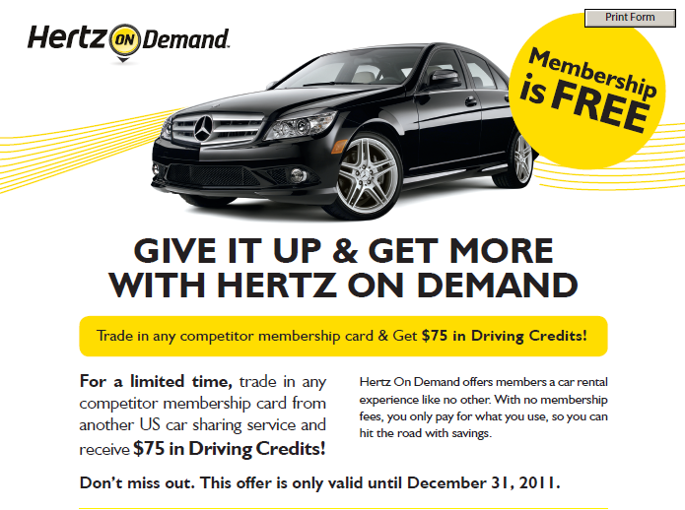
Exhibit 2: Hertz’s Zipcar Comparison
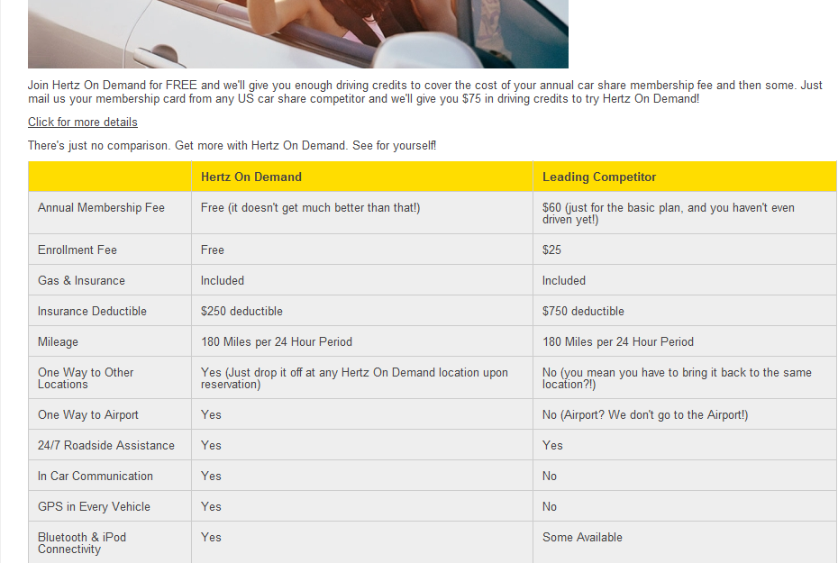
Exhibit 3: Enterprise Ad
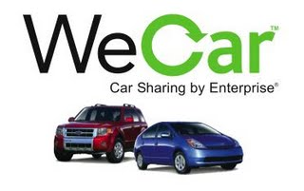

Exhibit 4: Enterprise Ad
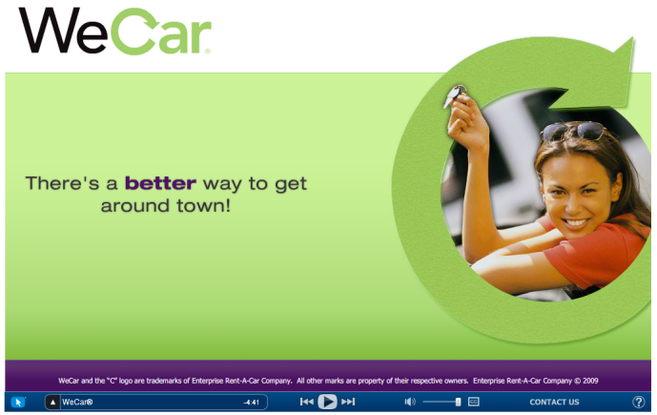

Exhibit 5: Positioning Map
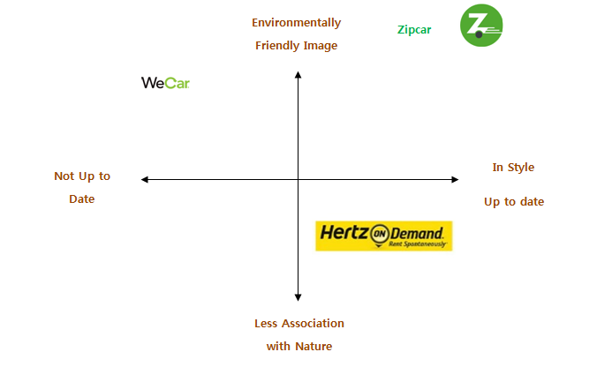
Exhibit 6: SWOT Analysis
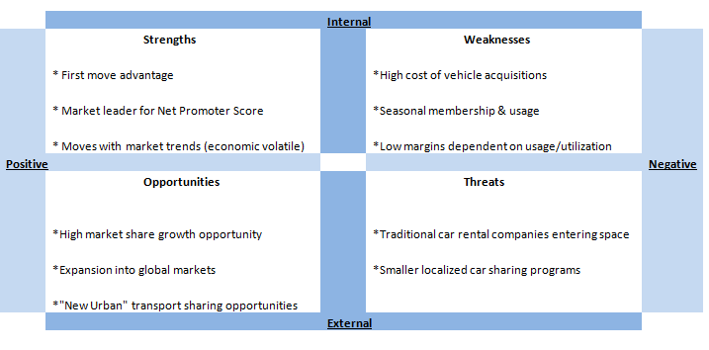

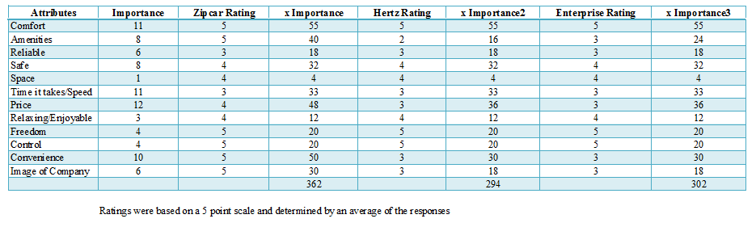
Exhibit 7: Multi Attribute Model
Exhibit 8: Chosen ZMET Examples

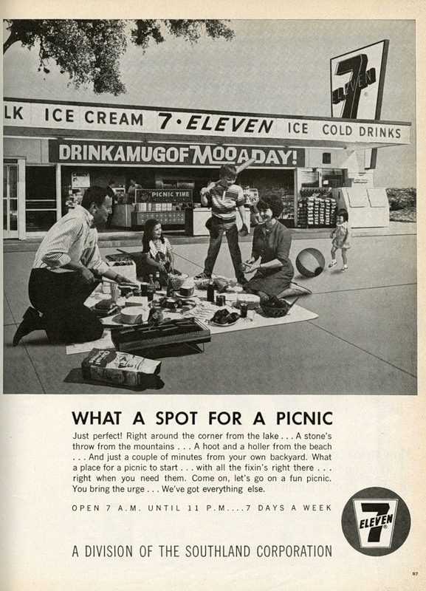
This ad highlights the convenience of 7-11 plus the green color in Zipcar’s logo. It’s an old ad but the words remind me of Zipcar it’s like we have everything you need to have a good time

Zipcar is just different than normal car companies, renting a car normally seems like such a hassle. Using Zipcar seems so much easier you just tap your card and you are ready to go. Zipcar is a new way of doing it.

This guy just seems so happy he’s standing on a mountain and he’s just so free, like I accomplished that I’m awesome, Zipcar kind of aids in that in a “I can take you anywhere you want to go so that you can climb a mountain” kind of way

I picked this picture because I don’t really understand how Zipcar works I mean I get the basic idea and I’ve seen some of their ads, but I don’t really understand what you have to do to get a car, how much it costs, anything like that

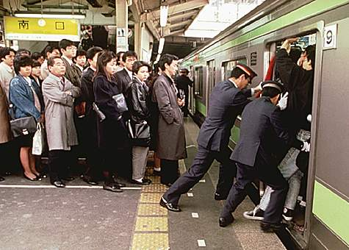

Subway:
-Being able to avoid this!
-Commuting can be such a pain sometimes, being able to drive once in a while to avoid this is so great
-Not crowded, comfortable traveling option

Exhibit 9: Guide to interviews

- Guide me through the process of when you travel? What words describe it?
- When do you need a car to travel? What else do you need a car for?
- When you are considering renting a car, what are the events that lead up to the decision how did you decide which option did you choose?
- Name all of modes of transportation you have taken in the past month
  - What is your favorite type?
  - What are the attributes you look for in a category
  - How important (on a scale from 1-5) is each attribute
  - How would you rate our brand vs. brand X and brand Y on each attribute
- What would be your perfect car renting experience?
- Imagine you are the creative director of a Zip car was sitting across the table and asked you about ideas for new advertising, what kinds of things would you tell her?

See Exhibit 1 for example of Hertz’s “Give it Up, Get More” promotion
See Exhibit 2 for example of Hertz’s Zipcar comparison
See Exhibit 3 for example of Enterprise advertising
See Exhibit 4 for example of Enterprise website
See Exhibit 5 for positioning map
See Exhibit 6 for a breakdown of the SWOT Analysis
See Exhibit 7 for Multi-Attribute Model
See Exhibit 8 for ZMETS
See Exhibit 9 for Interview Guide

