2008
ME 2024 - Industrial Marketing

Zhu Chu Sébastien Crespin Guillaume Favreau Xiaojia Hu Liang Huang Bo Peng

[Marketing Analysis of Porsche-Cayenne]

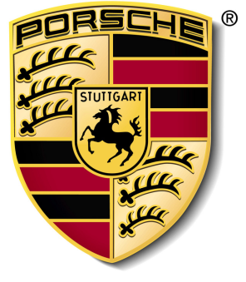

Table of Content

1 Company Portrait 3
1.1 Porsche Automobile Holding SE 3
1.1.1 Dr. Ing. h.c. F. Porsche AG 3
1.1.2 Porsche’s services 5
1.2 Product range of Dr. Ing. h.c. F. Porsche AG 5
2 Brand extension 6
2.1 Logo meaning 6
2.2 Cultural biography 7
2.3 Brand extension analysis of Cayenne 7
3 Brand positioning 9
3.1 Positioning Fundamental 9
3.2 Porsche’s frame of reference 9
3.3 Porsche’s points of difference 9
3.4 How Porsche sustain its position over time 10
3.4.1 Porsche‘s strategy to sustain Cayenne’s position over time 10
3.4.2 SWOT Analysis of Porsche 10
4 Advertisement of Porsche Cayenne 12
5 Brand value & comparison with Panamera 14
5.1 The initial meaning 14
5.2 Cayenne to Porsche 14
Conclusion 16
Appendix 1 – A Psychographic Profile of the Porsche Buyer 17

Company Portrait

Porsche Automobile Holding SE
Since June 2007, Dr. Ing. h.c. F. Porsche AG has a new company structure. The Porsche Automobile Holding SE was established to divide the stocks of the operating subsidiary Porsche AG from the investments in Volkswagen AG. Therefore Porsche Automobile Holding SE is only responsible for the management of the stocks. With that new structure the holding and operating activities of Porsche have been divided to ensure that the autonomy and independence of the automobile-manufacturing company will be protected. In March 2007 Porsche AG took its holding of Volkswagen shares to 30.9% and increased them to 35% in September 2008. The figure 3 below shows the subsidiaries of Porsche AG and Volkswagen AG.
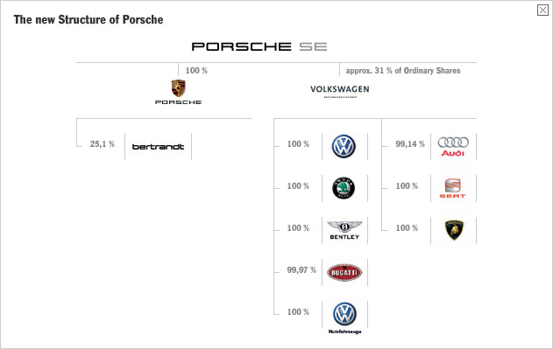
Figure 1 - Structure of Porsche AG

Dr. Ing. h.c. F. Porsche AG
Again and again Porsche brings forward new ideas. Around 3500 worldwide valid patents are administrated from the research and development centre in Weissach and they are growing every year. Developments have a very crucial influence on the automotive market and other industries as well. Innovations and marketing of industrial property rights have a very long tradition at Porsche.
Today Dr. Ing. h.c. F. Porsche AG employs around 11.400 employees. Hence Porsche is one of the smallest and most profitable independent automotive manufactures with a reckonable turnover of 7,368 Mio € and a return of 5,857 Mio € in the year 2006/07. In 2007 a total amount of 36.680 cars were sold which is an incensement of 2% compared to 2006.

Locations in Germany
Porsche AG has three business locations in Germany: Stuttgart, Leipzig and the development centre Weissach and Ludwigsburg.
Headquarter of Porsche AG is located in Stuttgart-Zuffenhausen. Besides the administration, including the management broad, the production of 911 and parts of Boxster is situated in Zuffenhausen. Till this day all Porsche engines are exclusively hand-crafted at this business location.
The location Leipzig was opened in 2002. There are the final assembly and delivery of the sport utility vehicle Cayenne and a cross-county course for demonstration and tests located.

Locations world-wide
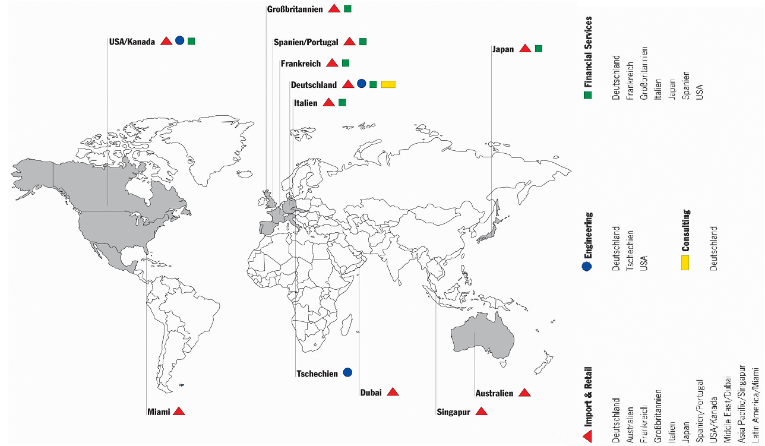
The Porsche brand stands world-wide for “Made in Germany”. Therefore internationalization and globalization respectively are a part of the company policy. More than 50 national and international companies belong to Porsche’s consolidated companies, amongst others from the divisions Marketing and Sales, Engineering, Financial Services and Consulting.

Figure 2 - Porsche's worldwide establishment

We see here that Porsche has understood the interest of building a global brand. By taking your existing brand into a global marketplace, you have more opportunities to leverage your company’s scale, expertise and core competencies. “You can benefit from the cross-pollination of ideas across countries. You can fine-tune and continually improve your best practices”. Besides, the benchmarking across the different countries allows you to quite often reduce the costs and save money.

Porsche’s services
Porsche’s organization is divided in several services that we are going to briefly introduce:
- Porsche Consulting, which helps companies to shape their processes more efficiently in development, purchasing, production/logistics and sales.
- Porsche Engineering, which offers development services and expertise in Porsche quality to its customers throughout the world.
- Financial Services, which provide its clients with customized financial solutions such as leasing and credit
- Marketing & Sales, Porsche has its own sales organization in each country in order to standardize sales and brands strategy in the most important markets in the world.
- Mieschke Hofmann und Partner, Service company of Porsche, which offers holistic process, IT consulting and comprehensive automotive know-how
- Porsche CAx Supplier, which provides information and tools to design engineering data with CAD and CAM for registered suppliers in the engineering environment

Product range of Dr. Ing. h.c. F. Porsche AG
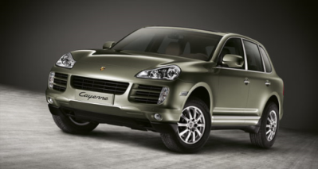
Porsche has developed several models over the past decades so that Porsche is now able to offer a complete rank of product always for the premium market. We can quote for instance the 911 model, perhaps the legend model of Porsche which has existed for over 40 years now. This model really embodies the Porsche typical design. Then comes the Boxster which is ranked in the leading position of the roadster category and which has been produced since 1996.
Figure 3 - Porsche Cayenne
With Cayenne, which is Porsche’s SUV (Sport Utility Vehicle), Porsche entered a totally new market that has been emerging for 10 years. We will focus our analysis on the Porsche Cayenne brand.
To finish with Porsche’s Portfolio, a new Porsche, the Porsche Panamera, is currently undergoing development and will be sold as the first sport coupé with four seats …
Figure 4 - Panamera
Beyond these models lies an important question: what is exactly the marketing strategy of Porsche? It is what we are going to define in the following parts.

Brand extension

Logo meaning
Porsche is the last name of Ferdinand Alexander Porsche who is the initiator of PORSCHE. The Porsche badge is essentially the coast of arms of the city of Stuttgart, which was built on the site of a stud farm – hence the horse. The character of “PORSCHE” is on the head of the logo, it indicates that the logo is assigned to PORSCHE. The character of “STUTTGART” claims that the head office of PORSCHE is Stuttgart. In the top left corner and bottom of right corner of the logo, we can see some antlers. They told us Stuttgart is the place has been a good place for hunting. In the top right corner and bottom of left corner of the logo, there are some red-and-black strips. Both the antlers and red-and-black stripes are part of the arms of the Kingdom of Württemberg.
Figure 5 - Porsche's logo

Figure 6 - coat of arms of Free People's State of Württemberg

Figure 7 - Coat of arms of Stuttgart
Porsche’s logo originated from the arms of its location (Stuttgart) and is combined with the coat of arms of Württemberg. With the arms of Stuttgart in the middle, making the logo we see today2.
Cayenne is Porsche’s first move outside the sports car real: it’s partly a sports car, and therefore very fast. Porsche named its new sport-utility vehicle the “Cayenne”, as in cayenne pepper, because it is recognized in almost every language for its hot qualities. Such as in Chinese, “Cayenne” means a banquet for triumph.
Figure 8 - Cayenne's logo

Cultural biography
Cultural biography is the local source of meaning in a global marketplace, a diachronic account of the brand as it evolves in concert with the forces of social life. It is a life history narrative. Porsche is famous by their sports car: in the past hundred years their always focused on product high class sport car. It was the company’s biggest risk, since the U.S. (Porsche’s biggest export market) already had 36 SUV in contention before Cayenne launched off assembly line. But the success of their brand strategy rests with their cultural biography. Cayenne is partly a sport car, and therefore very fast. In the other side, Cayenne still keeps Porsche’s irresistible memes in its current visage. Because the temporal ethos affects profoundly the way a brand is interpreted, Porsche has been a pronoun of sport cars in the past a hundred years. To reduce the risk of extending the brand in the SUV category, Porsche’s top managers have to make their new product in line extension. The meaning manager in Porsche also have a panoramic view of the brand as it evolves over time, and a deep understanding of the changing socio-cultural dynamics that shape the brand’s role in the lives of consumers3. They probed that there is still a share of the SUV market that the need of speed from consumer. Then they prepared to create this brand (Cayenne) to follow the speed culture in this society. Cayenne also follows the Porsche Principle which is Magna Carta. It is based on values and philosophies that together create their added value. This principle has been a matter of their standards. In addition to maximum cost-effectiveness, they comply with the high demands they made. What counts here are quality, environmental protection, safety, natural, and fascinating. All of these criteria are important to Porsche, since these requirements are all from the socio-cultural dynamics.

Brand extension analysis of Cayenne
Brand extend is a marketing strategy which refers to the use of a successful brand name to launch a new or modified product in a same broad market. Usually, successful companies use this strategy to launch new products, increase and leverage brand equity. In general, there are two types of brand extension, one is line extensions when the new products are in the same product category as the parent or flagship brand, and the other one is category extensions when they are in a different category than the parent brand.
Due to the fact that new products and services are very difficult to be accepted by the market, 9 out of 10 new products fail and are withdraw from the market with a year, therefore, brand extension is a very useful marketing strategy to help managing the costs and risks associated with launching a new product.
Different from the traditional sport cars, Cayenne is the first and only SUV car in Porsche’s family. On account of Cayenne breaks the traditional view that Porsche equals luxury sports car, it exists risks and costs to push cayenne into the market. It’s also a big challenge to make Cayenne be accepted by the market. A bad branding strategy would have directly leaded to the failure of launching this new SUV car. In order to launch Cayenne to the market, Porsche adopted a line extension strategy to entry into marketplace. Line extensions are usually introduced in response to consumers’ desire for variety in flavors, forms and package sizes. By using line extension strategy, the customer’s knowledge of Porsche such as high quality, fashion design and luxury is automatically transferred to cayenne. In addition, Cayenne can help Porsche to extend the target group, fit the variety tasty of customers so that to increase the share of car market. Therefore, we can say that correct brand strategy is one key factor for Cayenne’s further success.
In general, customer’s response to a brand extension depends on the level of fit that they perceive between parent brand and the extension brand. Customer understanding fits by determining whether these associations make sense in the context of the extension. Cayenne succeeds to fashion design and refined appearance of traditional Porsche car. In addition, Cayenne’s comfort, big inner space and good capability extend the traditional view of Porsche which also benefit the parent brand.
According to the characteristics of SUV and the traditional image of Porsche, Cayenne combines luxury appearance and security and comfort together. Due to Cayenne well-fits with the parent brand and fits for the customer’s understanding of the traditional Porsche image, it got the great successful in the market that Porsche was waiting for. During the year 2007, the selling number of Cayenne reached 20340 in the world which account for 1/3 of the whole selling number of Porsche. Cayenne’s success provides a good example of brand extension and well-fit with the parent brand. Therefore, we can conclude that efficient and correct marketing strategy such as branding strategies and marketing meaning are really important factors for new product’s success.

Brand positioning
In this part, we will try to determine and analyze the specific, intended meaning of the Porsche brand in the mind of its customers

Positioning Fundamental
Identifying the Porsche targeted consumers may be challenging but we can stress the main ones. Porsche is clearly targeting people with a high purchasing power who enjoy high driving sensations. The Cayenne’s clients are (at least most of them) males, fond of high speed cars with a high quality finishing. As a SUV, the cayenne particularly targets wealthy fathers who want to have a car offering space for the whole family, but also luxury and high driving skills in any field. Rich single men are also targeted and will be very sensitive to the brand and fashion image but also to the image of power that can be -to some extend- related to the owner’s sexual life.
The average age of a Porsche possessor is around 55. This figure perfectly highlights the category targeted: businessmen, senior managers, celebrities… most of them are living in big cities and have an urban lifestyle. For a further analysis, you can take a look to the appendix 1 dealing about the “psychographic profile of the Porsche Buyer”.

Porsche’s frame of reference
The frame of reference is the target’s goal that will be served by consuming the brand and thus here by purchasing and driving a Porsche Cayenne.
It seems obvious that the Cayenne claims membership in the SUV category. It competes with different car manufacturers such as BMW with theX5, Mercedes-Benz with the G-Class, Volvo with the XC90, Lexus with the Lexus RX… Thus we can identify the points of parity:
- A large carrier that can welcome at least five adults with all the comfort of a berline
- High driving skills in any field, despite that they are mainly used in cities
- Ability to draw caravans, boats…
- Luxury, high quality product
But the strength of the Cayenne is based on abstract consumer goals:
- A social image of power, wealth, sport and freedom
- To belong to a kind of “driving elite” that share values and the “Porsche attitude”

Porsche’s points of difference
The Cayenne is superior to other competitors at various level of abstraction. First we can distinguish the functional benefits. By purchasing a Cayenne, the consumer not only by a SUV but he also buys a sport car with all the know-how of a car manufacturer that has been producing high quality cars for decades. The level of requirement is pushed to the extreme for each item that composes the SUV. For the customer it is the guarantee of having a reliable car for the years to come.
Secondly, we can analyze the emotional benefits. One can’t deny the fact that having a Porsche Cayenne is not like having a “common car”. Such owners are proud to have a Cayenne and may feel superior to other drivers thus giving them a feeling of power. It is also for them a good way to achieve self-expression, show their social, financial success without voicing them, that can be perceived as pretentious. On the contrary, people will be impressed by the car and this prestige will be reported to the owner in an unconscious way and this one of the most powerful strength of the Porsche Cayenne brand.

How Porsche sustain its position over time

Porsche‘s strategy to sustain Cayenne’s position over time
Since its launch in 2002, Porsche Cayenne has evolved to sustain its position over time. The strategy of Porsche to enhance Porsche Cayenne position is a leveraging strategy. Indeed, Porsche decided to broaden the frame of reference of Porsche Cayenne to increase the demand for the brand.
In the facts now, what was Porsche leveraging strategy? Four years after the launch of the first SUV of the company, Porsche launched the second generation of Porsche Cayenne. With a new lifted face and a variation of models, this new generation targets a broader public than the previous one.
The new generation encompass: still the basic model, but also the Cayenne S, Cayenne GTS, Cayenne Turbo and Cayenne Turbo S. These new models are putting a little more “sport” in this SUV car. But why this “sportification” of the Porsche Cayenne which was initially introduced to radically change from the traditional 911 series cars? Well, as far as we are concerned, we think that by introducing a “more affordable car”, Porsche took the risk to lose his prestigious clients who were happy to belong to the upper class and the very restricted world of owners of a Porsche. So, in order to reinsure these consumers about the brand equity of Porsche, and to remind them that Porsche is still a sport-car oriented brand, Porsche increased engines efficiency and maximum speed of these models.
The case of the Porsche Cayenne Turbo S illustrates this strategy. Cayenne Turbo S has been built only for the 2006 model year first, as we said before, to provide a sportier car but also partly to compete with the Mercedes-Benz ML63 AMG
Finally, the new generation of Porsche Cayenne should arrive in the mid-2010. Still in a leveraging strategy of broadening the frame of reference, Porsche should play this time the card of the “environment-friendly” and “low CO2-emission” with a hybrid model in order to fit to the current trend of sustainable development.

SWOT Analysis of Porsche
In order to see how Porsche has managed to be a successful manufacturer for several decades, we can also make a SWOT analysis of the brand.

Strengths
Before Wendelin Wiedeking took over leadership, Porsche has been in severe trouble in the early 1990s. In order to manage the problems, Porsche reduced production costs and nowadays the efficient and effective production is one of Porsche’s core strengths.
Besides cutting production costs Porsche continually enlarged its product portfolio since 1993. Therefore, Porsche expanded a lot and can appeal to many target groups as nowadays not only traditional sports cars are offered but also SUVs as we have been able to see in the previous part.
The most important strength of Porsche is the image. Porsche embodies dynamism, sportiness and wealth. Therefore, driving a Porsche more than ever is a mean of showing ones’ success.

Weaknesses
Although Porsche has enlarged its product portfolio, Porsche is only producing large cars with powerful engines. These circumstances will be problematic in the future because of the climate discussion and the quickly increasing gas price.
In addition to that, Porsche did not create (yet) an ecological brand image like many other car manufacturers did by introducing hybrid cars (Lexus, Toyota) or efficient dynamics (BMW).
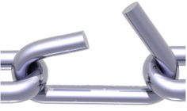
As Porsche is a comparable small player in the automotive world, Porsche does not have the advantage of economy of scale. This issue gets more and more important as prices for steel and aluminum increased dramatically during the last years. However, Porsche bought a considerable share of VW and can therefore probably get rid of this weakness in the future.

Opportunities
During the last years Russia, China and other countries, mainly from Asia, offer new markets as the economy grows quickly in these countries and more and more people can afford expensive cars like a Porsche.
Besides, Porsche bought a considerable share of VW. This strategy opens new possibilities like for example forming development cooperation. Thus, Porsche can in the future act as a real big player in the automotive world.

Threats
Since the target of Porsche remain wealthy people, the worldwide financial crisis can have negative effects on Porsche as people act more carefully and avoid buying expensive cars.
Moreover, the financial crisis can make another problem worse – the weakness of the dollar. As one of the most important markets for Porsche is the dollar area, Porsche will face problems if the exchange rate of the dollar does not stabilize.

Advertisement of Porsche Cayenne
Cayenne helps Porsche getting more and more amazing profit through the rapid increasing sales amount. This achievement relies on not only the brand force and excellent technical performance, but also the appropriate and accurate advertisements. Cayenne is the brand belongs to Porsche which is always considered as the representative of luxury, costliness and amazing mechanical performance. Only a few customers who are really rich can afford the price of Cayenne and own one. Porsche is the dream car for most of people all over the world.
The limitation of the customer and the specific attribute of Porsche decide the strategy of Cayenne’s advertisement should be different from the others. Comparing with the other car brand, such as VW, Toyota, Volvo and so on, it is very hard to find the advertisement of Cayenne on the TV program or daily newspaper.
The strategy of Cayenne’s advertisement follows one theory named Focus Marketing which is one of the most popular marketing rules nowadays. Focus Marketing is the method that analyses the market in the more detail and efficient way. Focus Marketing tries to classify the customer into accurate groups, and uses the specific advertising ways and campaigns to impact the end users. This method focuses on the pertinence and the veracity. Focus Advertising is the outcome of Focus Marketing. Cayenne is the successful example who uses Focus Advertising to do the brand extension and make huge profit.
The advertisement of Cayenne can be classified into four approaches: racing competition, professional auto magazine, “Christophorus” magazine and TV-Advertising. Porsche ripping integrates all these kinds of advertisements to find the target customers and guide and impact their consuming custom.
Cayenne Magazine
Racing Competition
TV
Advertising

Professional Auto Magazine
Cayenne’s Advertisement
Figure 9 - The four approaches of Cayenne’s advertisement
Racing Competition is the best stage where can show the car which has wonderful performance. All kinds of big car manufacturers choose joining racing campaign to increase their brand reputation and force. The most famous racing competition is known as Formula 1. Toyota, BMW, Renault and other big car manufacturers found their own super team to compete with other competitors in Formula 1. Some car manufacturers, such as BMW, have built their brand impact in the heart of customers deeply. This outcome helps the sales amount increasing remarkably. Porsche is also considered as one of the pioneers in racing competition. Cayenne as one important part of Porsche joins lots of really racing campaign, such as Siberian Rally Racing. Cayenne won the first three places in this Siberian Rally Racing finally. The wonderful performance in rally racing campaign represents the capacity of Cayenne and the builds the wonderful reputation.
Figure 10 - Photo of Cayenne in Siberian Rally Racing
Professional auto magazine is the other way to introduce the car brand to the end customers. It is the bridge between car manufacturer and potential consumer. Porsche has built the good relationship with the professional auto magazine, such as Car and Driver, Motor Trend, Road & Track, Automobile and so on. These magazines will help Porsche reaching the every corner in this world. Because the common people may not afford buying the Cayenne, but he can buy one magazine. Porsche provides the free testing car to these car magazines for writing the testing articles. These articles introduce the every aspect of Cayenne in the detail way. They can help the end customers knowing Cayenne well and giving them confidence to choose Cayenne.
“Christophorus” magazine is the other approach to extend the Cayenne brand. This magazine is published by Porsche itself. This magazine includes the latest news and introductions about Porsche Cars, and all kinds of information which relates to Porsche, such as Racing Race, the story of Porsche owner and so on. This magazine will be delivered to the potential customers by email or ordinary mail package. The potential customers are selected by the current database which includes all kinds of information concerning possible potential customers. This database is founded for a long period. Porsche uses lots of different approaches to gather the valuable customer’s information, such as the online subscription, filling out the campaign form, existing Porsche owners and so on. This approach increases the marketing efficiency and builds the brand loyalty of customers.
The reason of the resplendence of Cayenne is that Porsche uses the right advertising approach to extend its brand and explore market. Through the example of Cayenne, we can find the conclusion is that the appropriate advertisement is the effective way to lead to the success of brand and marketing.

Brand value & comparison with Panamera
Porsche Cayenne is an endorsed brand, the mother brand Porsche is still tied to the product brand Cayenne. In this case, Cayenne benefits from the standing of its mother brand Porsche and thus save the company a lot marketing expense by virtue promoting all the linked brands whenever the mother brand is advertised. On the other hand, if Cayenne did a great job on the market, Porsche can benefit from it as well. Since Porsche has already been an extremely acknowledged top-rank brand in the automobile industry and our topic mainly focus on Cayenne, how Cayenne is influencing Porsche cayenne will be discussed more in the following.

The initial meaning
There was a drastic debate while the CEO of Porsche Wendelin Wiedeking made the decision to launch Cayenne. And many of Porsche’s sport car fans were annoyed by the decision. Even the Porsche stakeholders thought it risky to make exclusive Porsche befit SUV. Then why did they make up the mind? If we look back to the vehicle market of last 2 decades, it’s easy to see that SUVs became extremely popular in the US, Canada, and Australia in the 1990s and early 2000s; this trend was known as the SUV craze. At that time, SUV is expected to be the mainstream of the future. As a celebrated brand that has more than hundred-year history, Porsche did not have its own SUV until 2002 when Cayenne is introduced. On the other hand, Porsche was struggling on the edge of dying. The significant decision is proved to be later--- Porsche has been doing great financially since then. Porsche now sells more Cayennes than its other two sports car lines (Boxster and 911) combined. Even the sports car fans have to admit that Cayenne helped a lot to save the company.
On Dec. 3, 2003, Porsche announced a 22% net profit increment, a period during which the global auto industry retracted. No wonder Business Week titled its story, "This SUV can tow an entire carmaker."

Cayenne to Porsche
Now that it is clear that Cayenne is a significant part of Porsche, the value of Cayenne will be discussed in the following part. To audit the brand’s strengths and weaknesses, we are going to apply Kevin Keller’s brand report card which listing 10 characteristics based on his review of the world’s strongest brands.
- The brand excels at delivering the benefits consumers truly desire. As mentioned, there was a big demand in the market, especially in the North American; people are crazy for the SUV. According to statistics, two-thirds of Porsche buyers owned at least two other vehicles, one of which was likely an SUV. That meant Porsche had been losing easy sales, and consequently easy profits, to other brands. Apparently, Cayenne fulfilled the anxious demand both from the consumer side and the company side.
- The brand stands relevant. Cayenne is exactly in touch with the customers’ taste, marketing condition of the time.
- The pricing strategy is based on consumers’ perception value. As usual, Cayenne is an exclusive brand in the SUV area. It sells for $56,000 to $110,000 in the North America. A fully loaded Cayenne Turbo can cost as much as $134,000, depending on options. Porsche made Cayenne deserve the price. Firstly, Porsche’s consistently excellent quality assurance made Cayenne born with a golden fame. Furthermore, while deciding launching Cayenne, there was no room at Porsche's main plants in Zuffenhausen. While VW set up for its SUV Touaregs in Slovak Republic, where labor costs were lower, Porsche refused to follow. They believe that "made in Germany" can get more reputation Cayenne.
- The brand is properly positioned. Porsche has got great reputation in the sport car domain. They continued to apply its sophisticated technology to Cayenne. The sport features was greatly demonstrated on Cayenne. Besides the off-load capacity, Cayenne keep the great speeding capability of Porsche. It can go from zero to 60 mph in 4.9 seconds (in manual mode), whereas the Mercedes-Benz G55, which is one of Cayenne’s main competitor, does it in 5.4 seconds.
- The brand consistency. SUV may not befit Porsche’s persistent public image of sport car, but it do did a great job on sales.
- The brand portfolio and hierarchy makes sense. Cayenne greatly expands Porsche’s market while earning more reputation for Porsche. Consequently, Porsche is planning to launch its first sedan “Panamera” in the near future. Except truck, Porsche now almost get all categories of vehicles.
- The brand makes use of and coordinates a full repertoire of marketing activities to build equity. Brand equity refers to the marketing effects or outcomes that accrue to a product with its brand name compared with those that would accrue if the same product did not have the brand name. Cayenne obviously did well in increasing Porsche’s brand equity.
- The brand’s managers understand what the brand means to consumers. From the very beginning, managers have been always clear about what the costumers like and dislike a Porsche SUV. The sales result obviously turned out to be good.
- The brand is given proper sustained support. From the development to the evolution and maintenance, Cayenne has received great support from Porsche and VW which is the cooperator of Porsche.
- The company monitors sources of brand equity. There are three main perspectives to view brand equity: financial, brand extension, and consumer-based.
- Financial: as one of the most expensive SUVs in the world, Cayenne did a great job on sales. Within a year of the U.S. launch, Business Week reported that strong Cayenne sales had helped Porsche pay down its debt to a modest $128 million and amass $2.1 billion in cash11.
- Extension: Only 18% of Cayenne buyers are Porsche clients, helping the sports-car maker broadens its customer base. 9This proved that Porsche gained both invisible brand asset extension and visible revenue extension.
- Consumer-based: said to be the fastest SUV in the planet, Porsche Cayenne deserves the price in the consumer’s perspective. The test driver was amazed by Cayenne’s excellent characteristics.

To sum up, Cayenne is of great value to Porsche. Not only did it helped Porsche solved the financial problem, Cayenne also greatly extended Porsche’s market from merely sport car fans to a much wider market. By seeing the success of Cayenne, Porsche got much more courage to launch the new product line—Panamera. If we look back to today 20 years later, we may find that Cayenne played an extremely critical role in Porsche’s history.

Conclusion

Appendix 1 – A Psychographic Profile of the Porsche Buyer
The report indicated that the typical owner is a 40-something male college graduate earning over $200,000 per year. The report further categorized owners into five personality types as follows:
Top Guns
Top Guns represent 27 percent of owners. These individuals are driven and ambitious. Of primary importance to them are the matters of power and control as well as a strong desire to be noticed.
Elitists
Elitists represent 24 percent of owners. These individuals are old-money blue bloods. To them, a car is just a car, no matter how expensive it happens to be. They do not feel that the car is an extension of the owner’s personality.
Proud Patrons
Proud Patrons represent 23 percent of owners. To this group, ownership is an end in itself. Their car is a trophy earned for hard work.
Bon Vivants
Bon Vivants represent 17 percent of owners. These individuals are worldly jet-setters and thrill seekers. To them, the car is a means of heightening the excitement in their busy lives.
Fantasists
Fantasists represent 9 percent of owners. To these individuals, their car is an escape. Feeling a little guilty about having a Porsche, they avoid impressing others with the fact that they own one.
As Mr. Ford glanced over the report, he thought of its possible implications to the two areas of car design and promotions. Concerning the first area, he wondered if it would be desirable to produce a different car model to fit the psychographic profile of each segment. Concerning promotions, he realized that ad appeals have to take into consideration both what motivates buyers and what turns them off. He regretfully recalled previous Porsche ads he once had approved that told buyers how good they look in the car and how fast they could go. He realized that those appeals were perhaps the wrong things to say when addressing a personality category such as the Elitists.

Kellogg on Branding, Alice M.Tybout and Tim Calkins, foreword by Philip Kotler, page 297
http://www.cartype.com/pages/1568/porsche access date: 2008-11-23
Kellogg on Branding, Alice M.Tybout and Tim Calkins, foreword by Philip Kotler, page 52
http://www.porsche.com/usa/aboutporsche/porschephilosophy/principleporsche/ access data: 2008-11-23
Kellogg on Branding, Alice M.Tybout and Tim Calkins, foreword by Philip Kotler, page 91
Kellogg on Branding, Alice M.Tybout and Tim Calkins, foreword by Philip Kotler, page 97
Kellogg on Branding, Alice M.Tybout and Tim Calkins, foreword by Philip Kotler, page 93
Business week, Porsche's Spicy Cayenne, December 19, 2007, http://www.businessweek.com/lifestyle/content/dec2007/bw20071219_836877.htm
The auto channel, Porsche Cayenne SUV - Success In A $90,000 Package, http://www.theautochannel.com/news/2003/12/15/174461.html
Kevin Keller, “The brand Report Card”, Harvard business Review (January – February 2000): pp.147-157
Porsche Cayenne History, http://auto.howstuffworks.com/porsche-cayenne-history.htm
Keller, Kevin Lane (2003). “Brand Synthesis: The Multidimensionality of Brand Knowledge”, Journal of Consumer Research, 29 (4),pp. 595-600
Consumer Behavior, Hanna and Wozniak, Prentice Hall, 2001, pp. 281-82

