Nike’s Risk Management and Derivative Usage

Quantifying Nike’s Exposure

In quantifying Nike’s Cash-Flow Exposure, we made the following assumptions.

Assumptions:
- Other revenue includes Emerging Markets, Global Brand Division, Other Businesses, and Corporate revenue and is assumed to be denominated in USD
- Other cost of sales sold includes a small number of countries other than Vietnam, China, and Indonesia and is assumed to be denominated in USD
- All SG&A is assumed to be incurred in the U.S. and denominated in USD
- The mean of the percentage changes in any currency exchange rate is assumed to equal 0%

  - Nike’s Future Cash Flow Exposures

We estimated that Nike will have an expected cash flow exposure (expected EBITDA) of $10,471 million for the next year with respect to the various currencies to which it is exposed. Nike will have to take short positions in the currencies in which it receives its revenue—namely, the EUR and the JPY—and long positions in the currencies in which it incurs its cost—namely, the VND, the RMB, and the IDR.

  - Nike’s Cash-Flow-At Risk
After performing a simulation on the distribution of Nike’s realized EBITDA for the next year, we estimated that Nike’s cash-flow-at-risk (Expected EBITDA with 95% confidence) over the next year is $9,160.50.

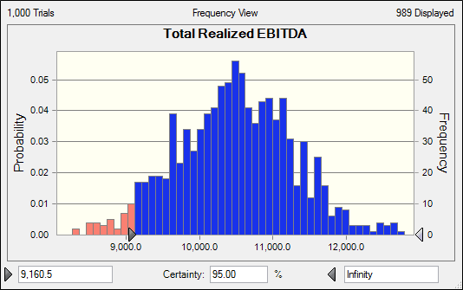

  - Nike’s Cash Flow Exposure With Hedging Policy
In their 10K, Nike discloses that “the company hedges up to 100% of anticipated exposures typically 12 months in advance,” and as a result we found it reasonable to assume that Nike will in fact hedge 100% of its anticiaptaed cash flow exposure and will hedge them precisely for a period of 12 months.
After taking into account the above assumptions regarding Nike’s hedging policy and the values of Nike’s forward positions in implementing the hedging, we found that Nike’s hedged EBITDA is expected to be $10,453.20. After performing a simulation on the distribution of Nike’s hedged EBITDA for the next year, we estimated that, with a 95% confidence level, Nike’s hedged EBITDA over the next year would equal at least $10,441.20.
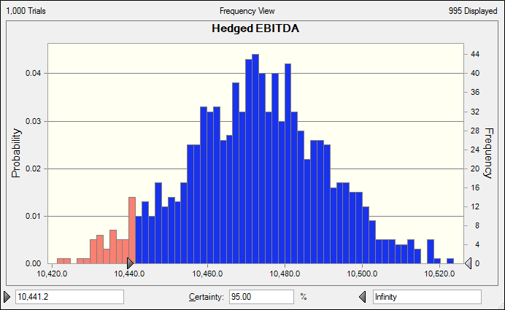

  - Why Does Nike Hedge?
Nike hedges in order to offset the risk associated with its exposure to foreign currency fluctuations. Since the company has entered into numerous contracts and commitments requiring it to make and receive payments in various foreign currencies, hedging provides an opportunity for Nike to lock in certain foreign exchange levels on which the company can rely with a specific confidence level.
The likely value added by Nike’s risk management and hedging policy is the amount that Nike would have lost had it not hedged its foreign currency exposure. Since the total value of Nike’s forward positions equals the exact opposite of Nike’s expected loss from cash flow exposure, then the value added by Nike’s risk management and hedging policy is equal to the total value of the company’s forward positions, or -$796 million; that is, for the next 12 months, Nike’s risk management and hedging policy is not expected to add any value, but instead erase $796 million of value.

